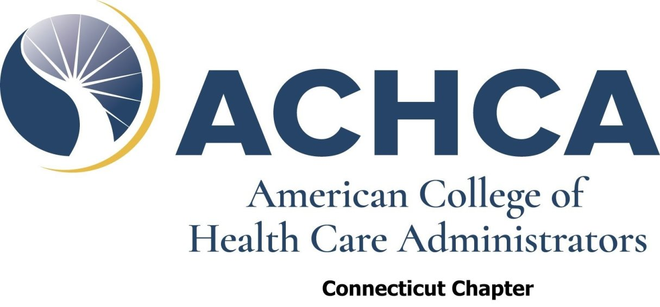

CALL FOR NOMINATIONS

The Connecticut Chapter of the American College of Healthcare Administrators is seeking nominations for the following positions:

Directors Two (2) for Two-year Terms

If you are interested in being nominated for any of the above positions, please submit the Nomination Form included in this packet by email to be received no later than Friday, March 21, 2025. You may nominate yourself or another qualified Connecticut ACHCA Active Member in good-standing.

In order to be nominated or hold any Officer or Board Member position, you must be a Connecticut ACHCA Active Member in good-standing. If you are unsure whether you meet this requirement, please check the Chapter website at www.ctachca.org/chaptermembers.htm where we have posted the latest list from National ACHCA. SEE, also, the Chapter By-laws posted to our website at www.ctachca.org/chapterbylaws.htm.

There is no nominating committee. All persons who meet the qualifications and submit the Call For Nominations form within the prescribed deadlines will be placed on the ballot.

If you have any questions, please do not hesitate to contact me at pneagle@touchpointsatmanchester.com.

Patrick Neagle
President and Chair Nominating Committee
CT ACHCA

NOMINATION FORM

Please print all information.

You will receive an e-mail acknowledging receipt of your nomination.

Position Sought:

Name of Person
To Be Nominated:

Address:

Telephone:

E-mail:

You may submit this application by posted mail or fax. If an application is illegible, incomplete or not received no later than Friday, March 21, 2025, the person nominated will not be included on the Ballot for election. There are no nominations from the floor at the Annual Meeting.

By email as an attachment, please send to:

pneagle@touchpointsatmanchester.com

