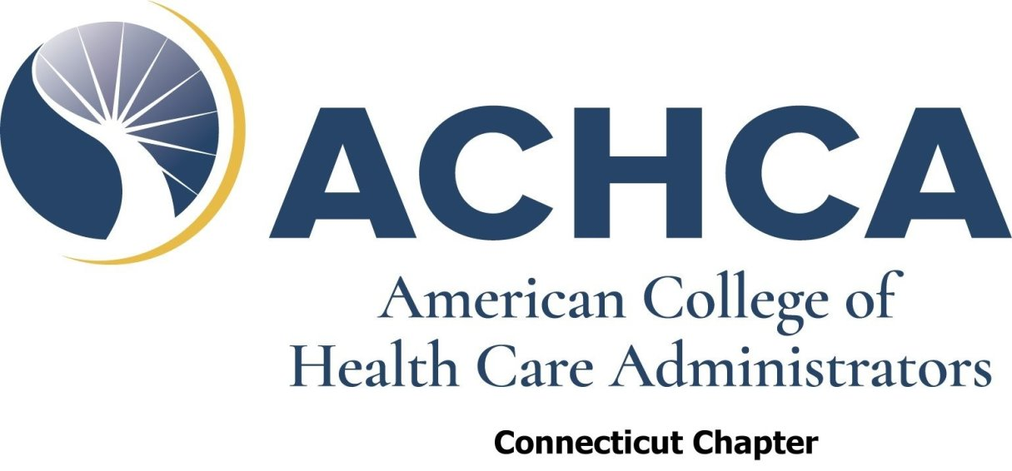

February 18, 2025

To: All Connecticut Chapter Members

From: Patrick Neagle, President, Connecticut Chapter ACHCA

Re: Nominations for Connecticut Certified Nursing Assistant Hall of Fame Class of 2025
______________________________________________________________________

As long-term care professionals, we all strive for new ways to recognize and reward our staff members. The Connecticut Chapter of ACHCA can help you to publicly recognize a valuable and compassionate Certified Nursing Assistant in your organization. Please find attached the information and application for the Connecticut Certified Nursing Assistant Hall of Fame.

Candidates that are selected to the Certified Nursing Assistant Hall of Fame may invite staff and family members for special luncheon and awards presentation ceremony. The awards ceremony has produced very moving and special moments for CNAs, their families, and staff members. We strongly encourage you to nominate a CNA that deserves this recognition for their years of dedication and care-giving.

A maximum of (6) six CNA’s will be inducted into the Nineteenth Annual Certified Nursing Assistant Hall of Fame during our Annual Meeting in March. If your Nominee from previous years was not recognized, submit them again!

If you wish to nominate a CNA, please forward a fully completed application by the deadline. You must also include documentation from the Connecticut Nurses Aide Registry Verification showing no negative findings of abuse, neglect or misappropriation of resident’s property. The verification must be dated after December 31, 2024.

Please e-mail send completed application to Erica Roman, Immediate Past President of the ACHCA CT Chapter to eroman@greenwichwoods.com.

Applications must be received by Friday, March 7, 2025.

APPLICATION

Connecticut Chapter
American College of Health Care Administrators

CERTIFIED NURSING ASSISTANT HALL OF FAME

Nominations for the 2025 Certified Nursing Assistant Hall of Fame are now being accepted for all qualified candidates.

The purpose of the Certified Nursing Assistant Hall of Fame is to recognize nursing assistants who have consistently rendered the highest quality of care and promote exceptional quality of life to residents in long term care facilities in Connecticut.

INSTRUCTIONS FOR NOMINATORS:

1) The CNA must be nominated by an ACHCA Connecticut Chapter
Member in good-standing who is the Administrator-of-record of the facility at which the CNA is currently employed.
2) Only one (1) CNA per facility may be nominated.
3) The CNA must have worked a minimum of twenty (20) years of verifiable
service as a CNA in long-term care facility.
4) The CNA must be working presently at a long-term care facility.
5) The nominator must sign an attestation that the nominated CNA has worked
for (20) twenty years as a CNA and submit documentation from the CNA
registry that the CNA has no negative findings of abuse, neglect, or
misappropriation of resident’s property. The verification must be dated after
December 31, 2024.
6) The nomination must include a statement by the nominator that outlines why
the nominated CNA should be considered for induction into the Hall of
Fame, such as their standards for delivery of quality of care, and quality of life
to residents, volunteerism or any other outstanding attributes.

Please remember that the nomination must be signed by the ACHCA member in good-standing.

The CT Chapter Board of Directors or an established Committee will review all
nominations and will select inductees based upon a review of each application.

If your nominated CNA is selected to be inducted, the CT Chapter will invite the nominator and inductee and one (1) guest to the CT Chapter’s Annual Meeting and Award Ceremony as our guests. Additional guests may register at the Member cost. At the Annual Meeting, the CNA will be honored and inducted into the Hall of Fame and presented with an inscribed plaque. Their name will be placed in the CT Chapter’s Website “CNA Hall of Fame” section.

Pg 1 of 2

NOMINATION FOR CONNECTICUT
CERTIFIED NURSING ASSISTANT
HALL OF FAME

Name of Nominator: ____________________________________

Name of CNA: ______________ _______________________

Number of Years individual
has worked as a CNA: __________

Average # of hours
worked per week: _________________________________

Name/Address of facility that CNA
is currently working in: ____________________________________
____________________________________
____________________________________

Briefly describe why the CNA being nominated should be considered
for the Connecticut Certified Nursing Assistant Hall of Fame: Please use only
this area and do not include additional pages; please type.

PLEASE ENCLOSE VERIFICATION FROM THE CT CNA REGISTRY DATED AFTER DECEMBER 31, 2024. ANY NEGATIVE FINDINGS WILL DISQUALIFY THE CANDIDATE.

Pg 2 of 2

ATTESTATION

As the Nominator, I attest to the following:

1) The Certified Nursing Assistant that I am nominating for induction into the Connecticut Certified Nursing Assistant Hall of Fame has worked for a least (20) twenty years as a Certified Nursing Assistant, and that

2) I am the Administrator-of-record for the facility at which the Certified Nursing Assistant is currently employed, and that

3) I am a Member in good-standing with the American College of Health Care Administrators.

________________________________ ___/___/___
Signature of ACHCA Member, Nominator Date

